Apple Airpods 2nd Generation
Afrin Aktar
English Department at City College of New York
ENGL 21007: Writing For Engineering
Professor Julia Brown
March 26th , 2022
Table of Contents
Definition 3
Overview 3
Components 3
Explanation 5
Visuals 6
Conclusion 9
References 10

Definition
Airpods are wireless headphones. Airpods are an alternative for people who dislike wired headphones. Airpods are used to listen to any type of audio such as music, phone calls, voicemails, voice notes, videos, etc. You can connect your airpods to all of your devices, you are able to set it up through bluetooth. (Pause, Skip, and Adjust Volume With Your AirPods and AirPods Pro, 2021)

Overview
The second generation airpods are white, have an earbud-and-stem design, and come with a square-shaped case with a lid on its shortest length and an interior status LED. The second-generation airpods are the only airpods that have a longer stem than the other generations. It is also the only airpods generation to have a square shaped case. This case is used to protect your airpods, as well as a way to charge them. You charge the case in order to charge your airpods. You can charge your airpods wirelessly and with a regular iPhone charger. And according to Apple, you are able to have about 5 hours of listening time with your airpods as well as 3 hours of talking time on the phone. The airpods charging case allows you to listen to music, watch videos and more for more than 25hrs, and you can do this by quickly charging your airpods for about 15 minutes. (Pause, Skip, and Adjust Volume With Your AirPods and AirPods
Pro, 2021)

Components
There are multiple components that allow airpods to fulfill its main function, which is to be able to listen to audio wirelessly.
Earbuds:
The earbuds are essentially the airpods. It was something you would put in your ears to listen to your audio. These earbuds have grilles for a speaker, microphone holes that are used for noise-canceling secondary mics, and accelerometers which sense when you put the earbuds in your ear and when you take them out. Each earbud is labeled with an L or an R. (Johnson, 2021) The purpose of this labeling is to make sure you know which earbud goes in which ear.
Inside each earbud, there is a lot more technology. It contains wires, boards, cables, and more. There is a coaxial connector, which is a transmission line. This is used to carry high-frequency electrical signals with low losses. At the bottom of the stem of the earbuds, there is the end of the battery cable of the earbuds. This battery cable allows for the earbuds to be able to charge.
Overall, the earbuds are made up of Apple 343500130 is suspected to be the W1 wireless communication chip, Cypress CY8C4146FN programmable system on a chip, Maxim MAX98730EWJ low power stereo audio codec, Texas Instruments TPS62743 300 mA DC-DC buck converters, Bosch Sensortec BMA282 accelerometer, STMicroelectronics accelerometer/gyroscope, as well as serial flash memory. (AirPods Teardown, 2016)
Charging case:
The charging case is typically used to charge your airpods/earbuds as well as protect them. The case has a 3.81 V, 1.52 Wh lithium-ion. This is the battery of the charging case, and it has 16 times the power capacity than the battery in the earbuds. On the bottom of the charging case there is a lightning port. This lightning port is what is used to connect your charger. The case also has a LED light. This is used to show the status of your airpods as well as the charging case. When the light is green it means that your airpods are charged, and when it is orange it indicates that your airpods are low and need charging. The same can be said for your charging case. When you take out your airpods from the case, and if the light is orange it means that your case needs to be charged and when it's green it is charged.
On the back of the charging case there is a button. It is a pushbutton switch. This button is used to set up/ connect your devices using bluetooth. You would have to hold the button until the LED light turns white and then you follow the directions on your device to connect it.
Lastly, the charging case contains a logic board. The logic board contains,
STMicroelectonics STM32L072 ARM Cortex-M0+ MCU, NXP Semiconductor CBTL1610A3 charging/port controller IC, Texas Instruments BQ24232 power management IC, Maxim
Integrated MAX9028 1.8 V comparator, AMS AS3441 power and communication interface, and ON Semiconductor regulators. (AirPods Teardown, 2016)

Explanation
All of the parts of the Airpods 2nd generation allows it to fulfill its function. You are able to connect your airpods to your devices using bluetooth, as well as the main function of airpods which is to be able to listen to your audio for up to 5 hours of listening time. The earbuds allow you to listen to your music/audio because it has grilles for a speaker, microphone holes that are used for noise-canceling secondary mics, accelerometers and more, which are all components that allow for audio to be heard. And the charging case allows for your airpods to be charged, it also allows you to connect to other devices through bluetooth and protects your airpods. These are all components that allow you to listen to your music, phone calls, voicemails, and other audio.

Visuals
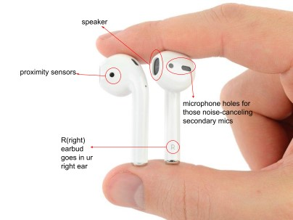
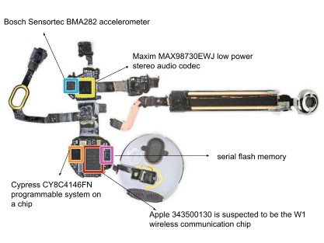
Figure 1
(AirPods Teardown, 2016)
Figure 2
(AirPods Teardown, 2016)
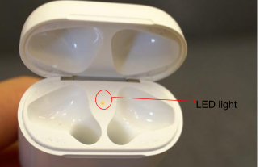
Figure 3
(Long Term Review: Apple's AirPods Are Still the Best Wireless Headphones Around, 2018)
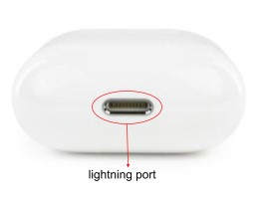
Figure 4
(AirPods Teardown, 2016)
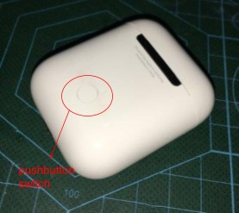
Figure 5
(AirPods Teardown, 2016)
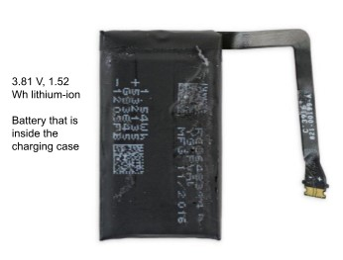
Figure 6
(AirPods Teardown, 2016)
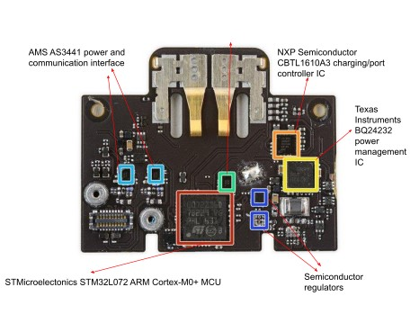
Figure 7
(AirPods Teardown, 2016)

Conclusion
In conclusion, Apple airpods 2nd generation were the turning point for wireless headphones. Airpods' evolution from wired headphones changed the game in the way society listens to music now. The Airpods 2nd generation currently retails at $129. (Pause, Skip, and Adjust Volume With Your AirPods and AirPods Pro, 2021) It is available through online purchase on the apple website, as well as in store at the Apple store and stores that sell apple products such as Best Buy or T-mobile.

References
AirPods Teardown. (2016, December 20). iFixit. Retrieved March 26, 2022, from https://www.ifixit.com/Teardown/AirPods+Teardown/75578
Long term review: Apple's AirPods are still the best wireless headphones around. (2018, July
10). AppleInsider. Retrieved March 26, 2022, from https://appleinsider.com/articles/18/07/10/long-term-review-apples-airpods-are-still-the-b est-wireless-headphones-around
Johnson, D. (2021, July 18). What Are AirPods and How Do They Work? Lifewire. Retrieved
March 26, 2022, from https://www.lifewire.com/what-are-airpods-4766801
Pause, skip, and adjust volume with your AirPods and AirPods Pro. (2021, October 25). Apple
Support. Retrieved March 26, 2022, from https://support.apple.com/en-us/HT212203
Gideon, T. (2021, October 25). Apple Earbuds Do Battle: AirPods (3rd Gen) vs. AirPods (2nd Gen) vs. AirPods Pro. PCMag. Retrieved March 26, 2022, from https://www.pcmag.com/news/apple-earbuds-do-battle-airpods-3rd-gen-vs-airpods-2nd-g en-vs-airpods-pro

